Master-detail сценарий
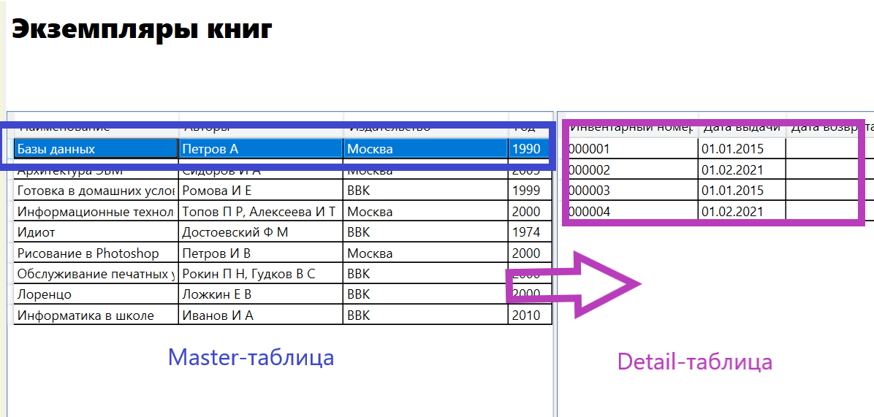
XAML
<Page x:Class="TestApp.Pages.CopyPage"
xmlns="http://schemas.microsoft.com/winfx/2006/xaml/presentation"
xmlns:x="http://schemas.microsoft.com/winfx/2006/xaml"
xmlns:mc="http://schemas.openxmlformats.org/markup-compatibility/2006"
xmlns:d="http://schemas.microsoft.com/expression/blend/2008"
xmlns:local="clr-namespace:TestApp.Pages"
mc:Ignorable="d"
d:DesignHeight="450" d:DesignWidth="800"
Title="CopyPage">

<Grid x:Name="CopyGrid">
<Grid.RowDefinitions>
<RowDefinition Height="50"/>
<RowDefinition Height="50"/>
<RowDefinition Height="*"/>
</Grid.RowDefinitions>
<Grid.ColumnDefinitions>
<ColumnDefinition Width="*" MinWidth="200"/>
<ColumnDefinition Width="3"/>
<ColumnDefinition Width="300" MinWidth="200"/>
</Grid.ColumnDefinitions>
<Label Content="Экземпляры книг" Grid.Row="0" Grid.Column="0" Grid.ColumnSpan="2" FontSize="26" FontWeight="ExtraBold"/>
<!--Master-таблица-->
<DataGrid x:Name="BookDataGrid" Grid.Row="2" Grid.Column="0" AutoGenerateColumns="False" CanUserAddRows="False" Background="White">
<DataGrid.Columns>
<DataGridTextColumn Header="Наименование" Binding="{Binding Path=Name}" Width="10*"/>
<DataGridTextColumn Header="Авторы" Binding="{Binding Path=Authors}" Width="10*"/>
<DataGridTextColumn Header="Издательство" Binding="{Binding Path=Publishers.PublisherName}" Width="10*"/>
<DataGridTextColumn Header="Год" Binding="{Binding Path=PublishYear}" Width="40"/>
</DataGrid.Columns>
</DataGrid>
<GridSplitter x:Name="BookCopyGridSplitter" Grid.Column="1" Grid.Row="2" Width="3" HorizontalAlignment="Stretch" />
<!--Detail-таблица-->
<DataGrid x:Name="CopyDataGrid" ItemsSource ="{Binding ElementName=BookDataGrid, Path =SelectedItem.Copies}" Grid.Row="2" Grid.Column="2" AutoGenerateColumns="False" CanUserAddRows="False" Background="White">
<DataGrid.Columns>
<DataGridTextColumn Header="Инвентарный номер" Binding="{Binding Path=InvNum}" Width="10*"/>
<DataGridTextColumn Header="Дата выдачи" Binding="{Binding Path=CommissionDate, StringFormat=\{0:dd.MM.yyyy\}}" Width="80"/>
<DataGridTextColumn Header="Дата возврата" Binding="{Binding Path=DecommissionDate, StringFormat=\{0:dd.MM.yyyy\}}" Width="90"/>
</DataGrid.Columns>
</DataGrid>

</Grid>
</Page>

<!--Detail-таблица-->  <DataGrid x:Name="CopyDataGrid" ItemsSource ="{Binding ElementName=BookDataGrid, Path =SelectedItem.Copies}" Grid.Row="2" Grid.Column="2" AutoGenerateColumns="False" CanUserAddRows="False" Background="White"> | 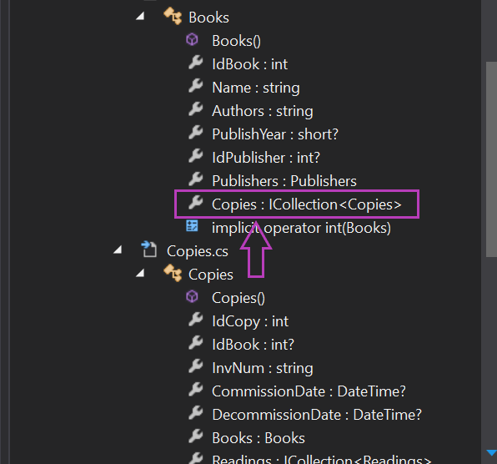

CS
//Определение источника данных для Master-таблицы
using System.Collections.ObjectModel;

namespace TestApp.Pages
{
/// <summary>
/// Логика взаимодействия для CopyPage.xaml
/// </summary>
public partial class CopyPage : Page
{
public ObservableCollection<Base.Books> Books;
public CopyPage()
{
InitializeComponent();
Books = new ObservableCollection<Base.Books>(SourceCore.MyBase.Books);
BookDataGrid.ItemsSource = Books;
}
}
}

